## Sagebrush and height measurement

The approximate sagebrush and grass height is about:

|  |  |  |  |  |  |  |
| --- | --- | --- | --- | --- | --- | --- |
| Unit: ft-in | Sample | Sample | Sample | Sample | Sample | Sample |
| Sagebrush | 5'2" | 4' | 6'3" | 2'10" | 4'8" | 7'4" |
| Grass | 1'5” | 1'3" | 2'4" | 10" | 2'7" |  |

Or

|  |  |  |  |  |  |  |  |
| --- | --- | --- | --- | --- | --- | --- | --- |
| Unit: meters | Sample | Sample | Sample | Sample | Sample | Sample | Simple Average |
| Sagebrush | 1.6 | 1.2 | 1.9 | 0.9 | 1.4 | 2.2 | 1.5 |
| Grass | 0.3 | 0.4 | 0.7 | 0.3 | 0.8 |  | 0.5 |

Photos for the measurement are attached below:

## Sagebrush measurement photos

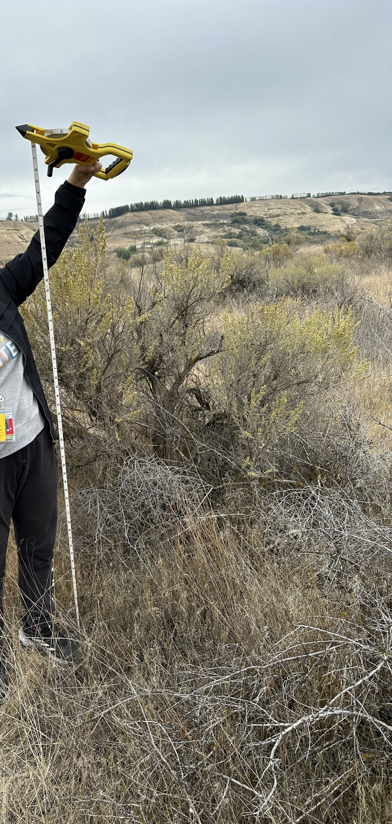

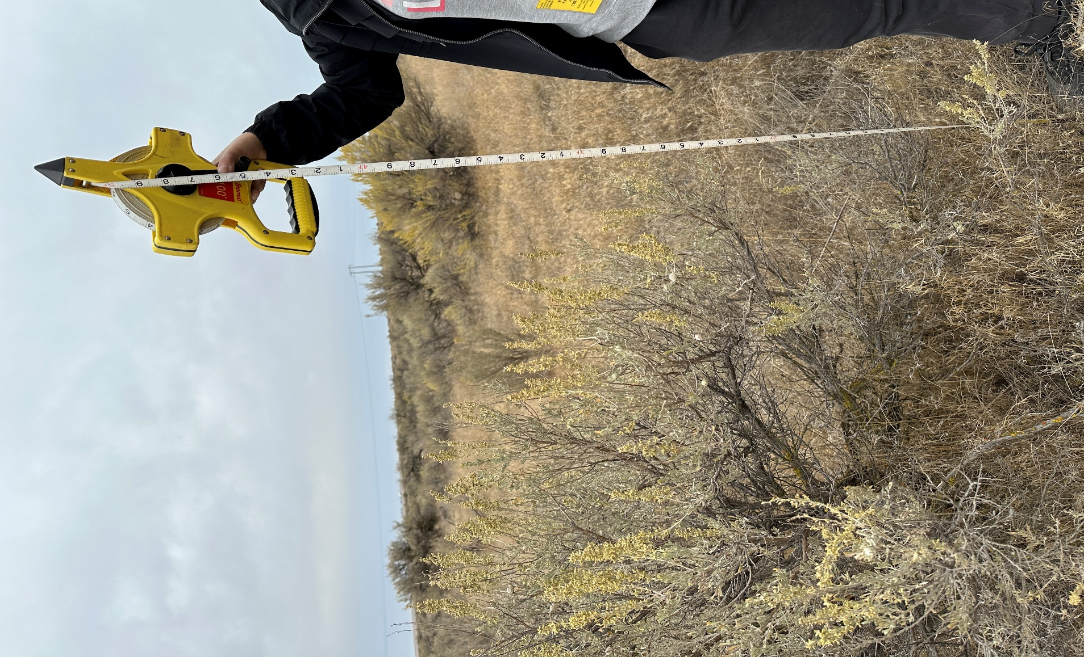

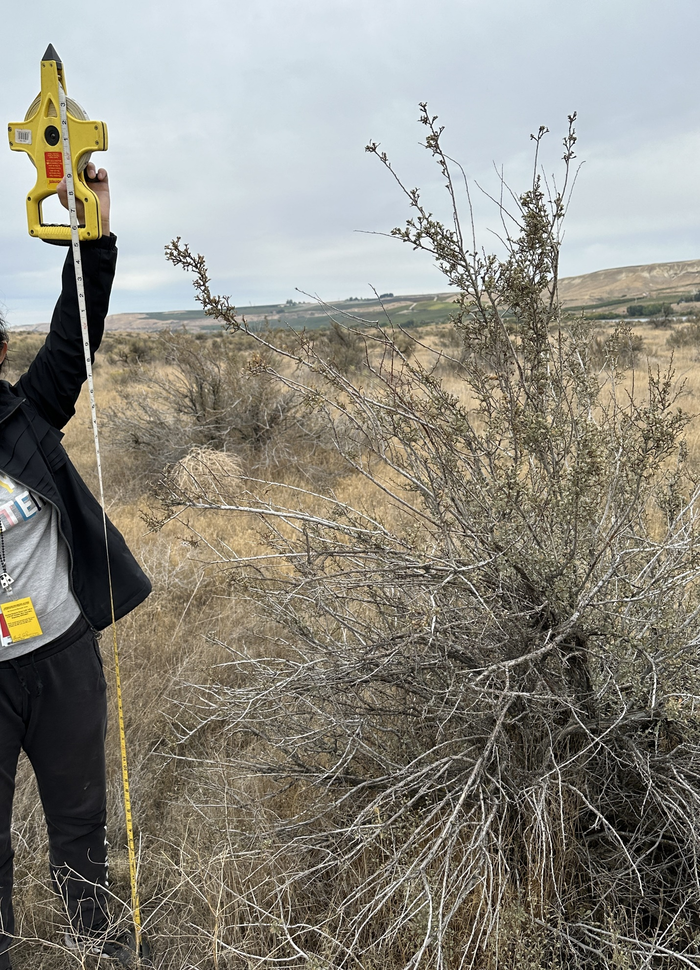

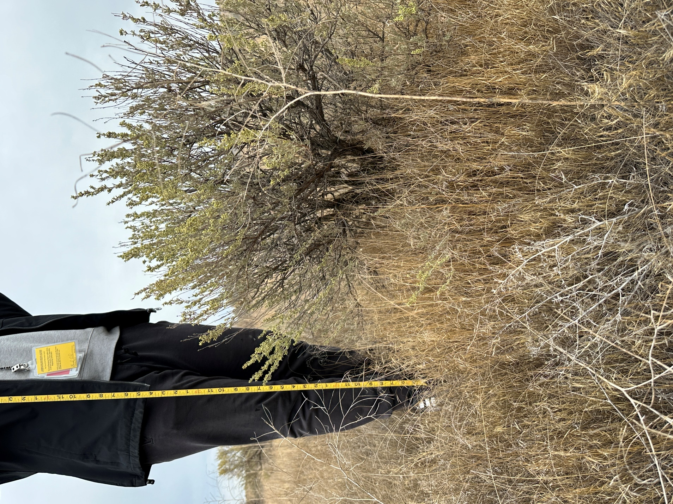

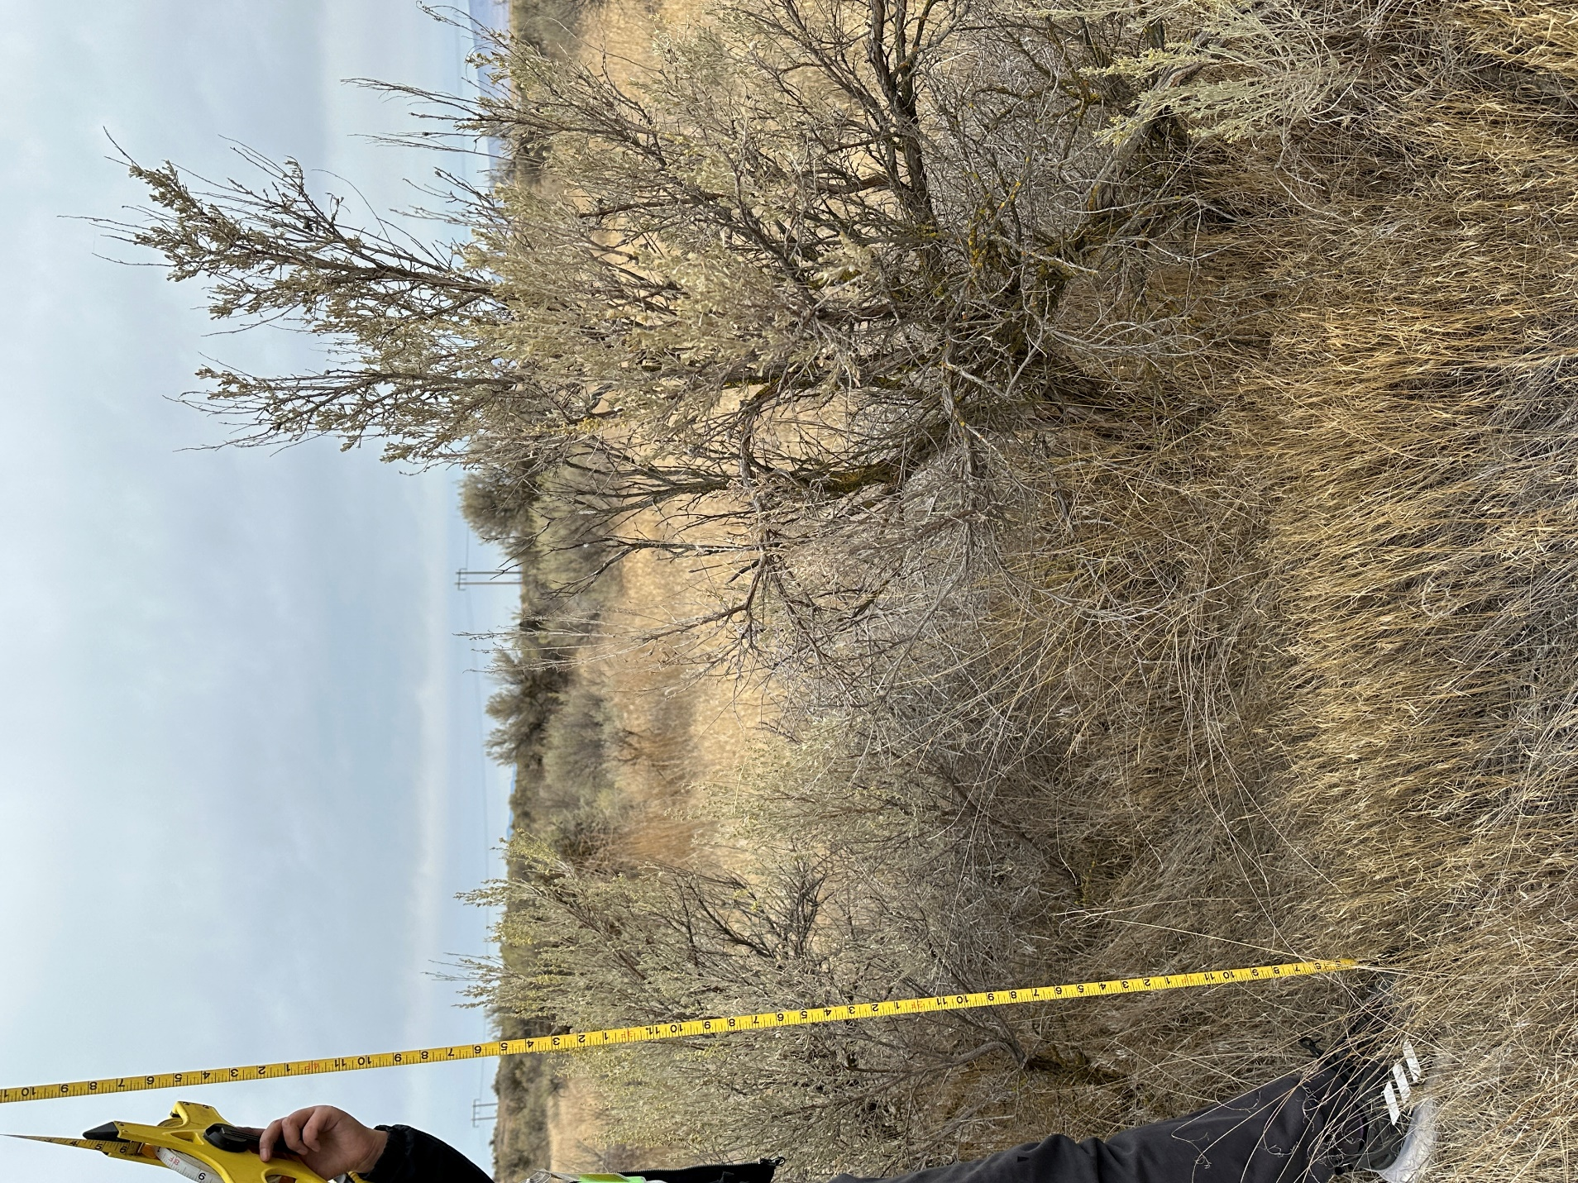

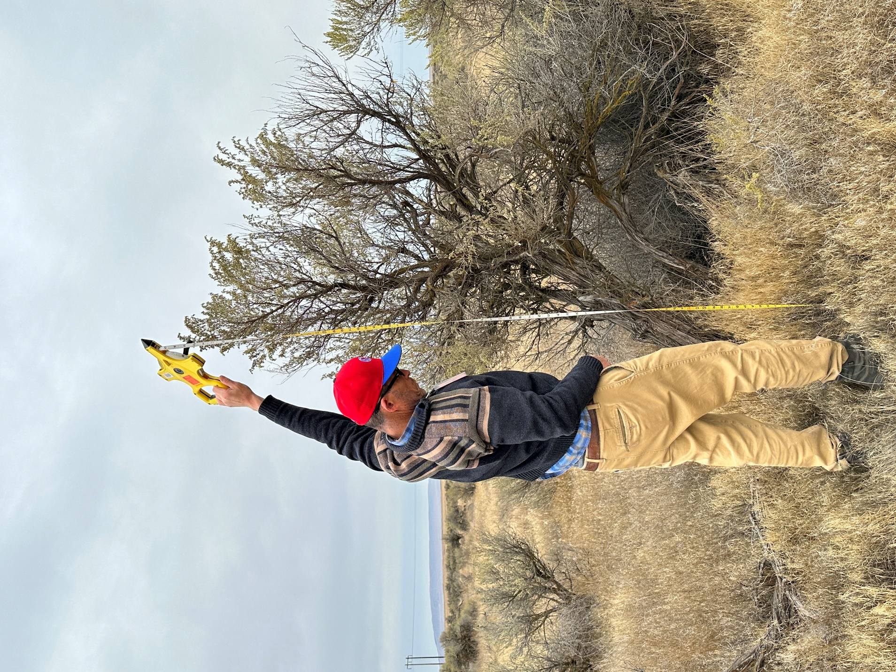

## Grass measurement photos

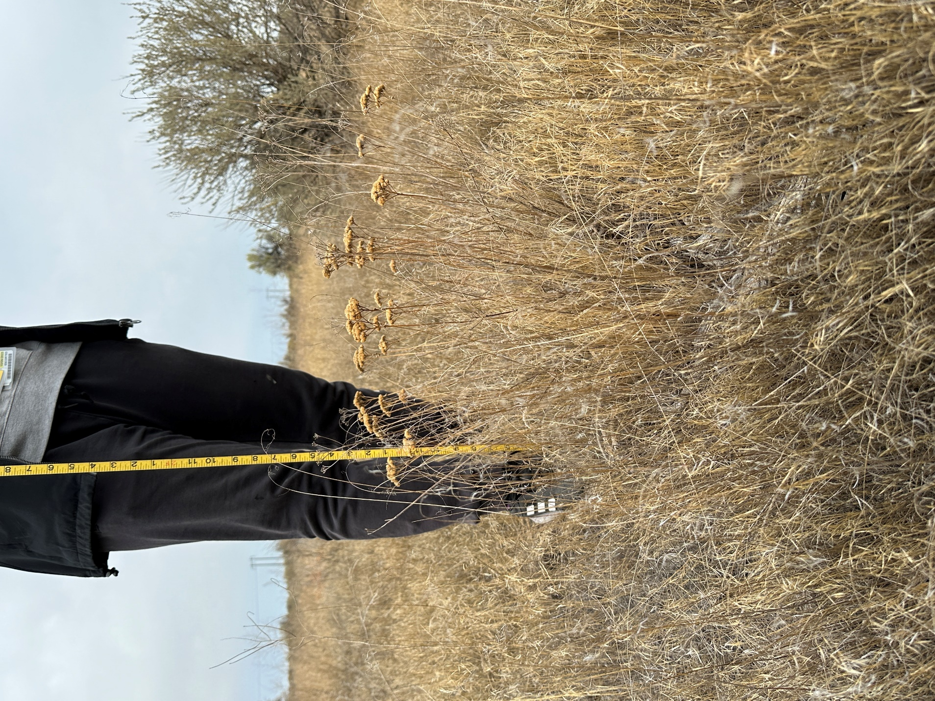

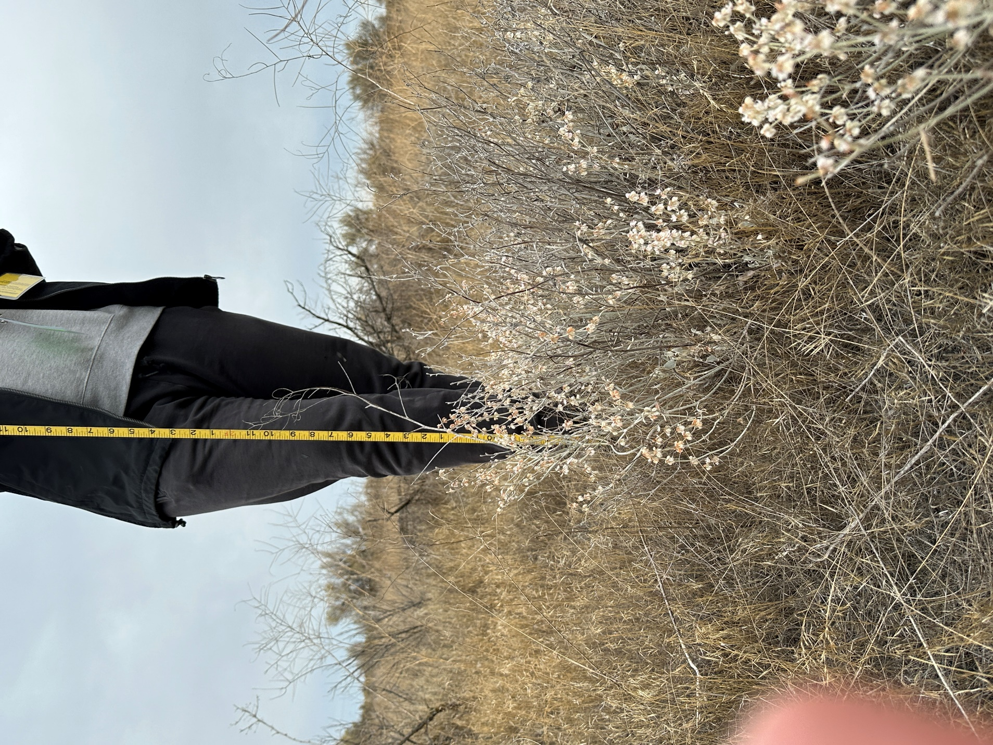

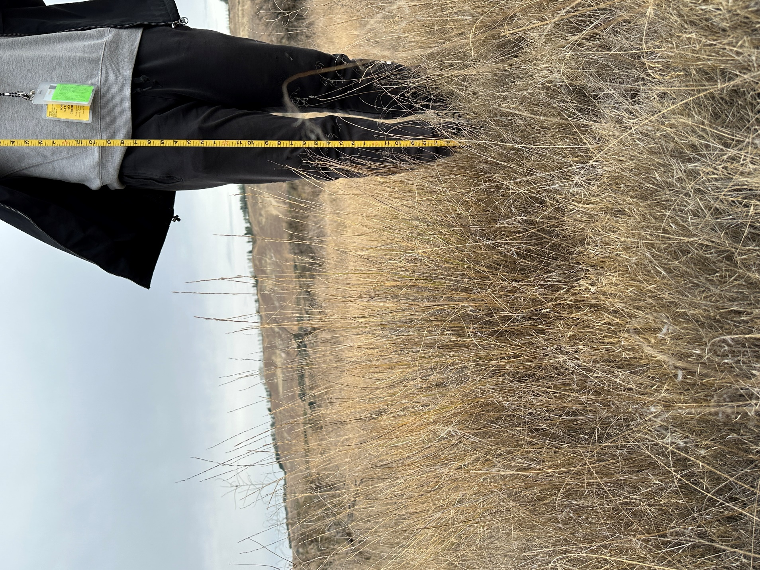

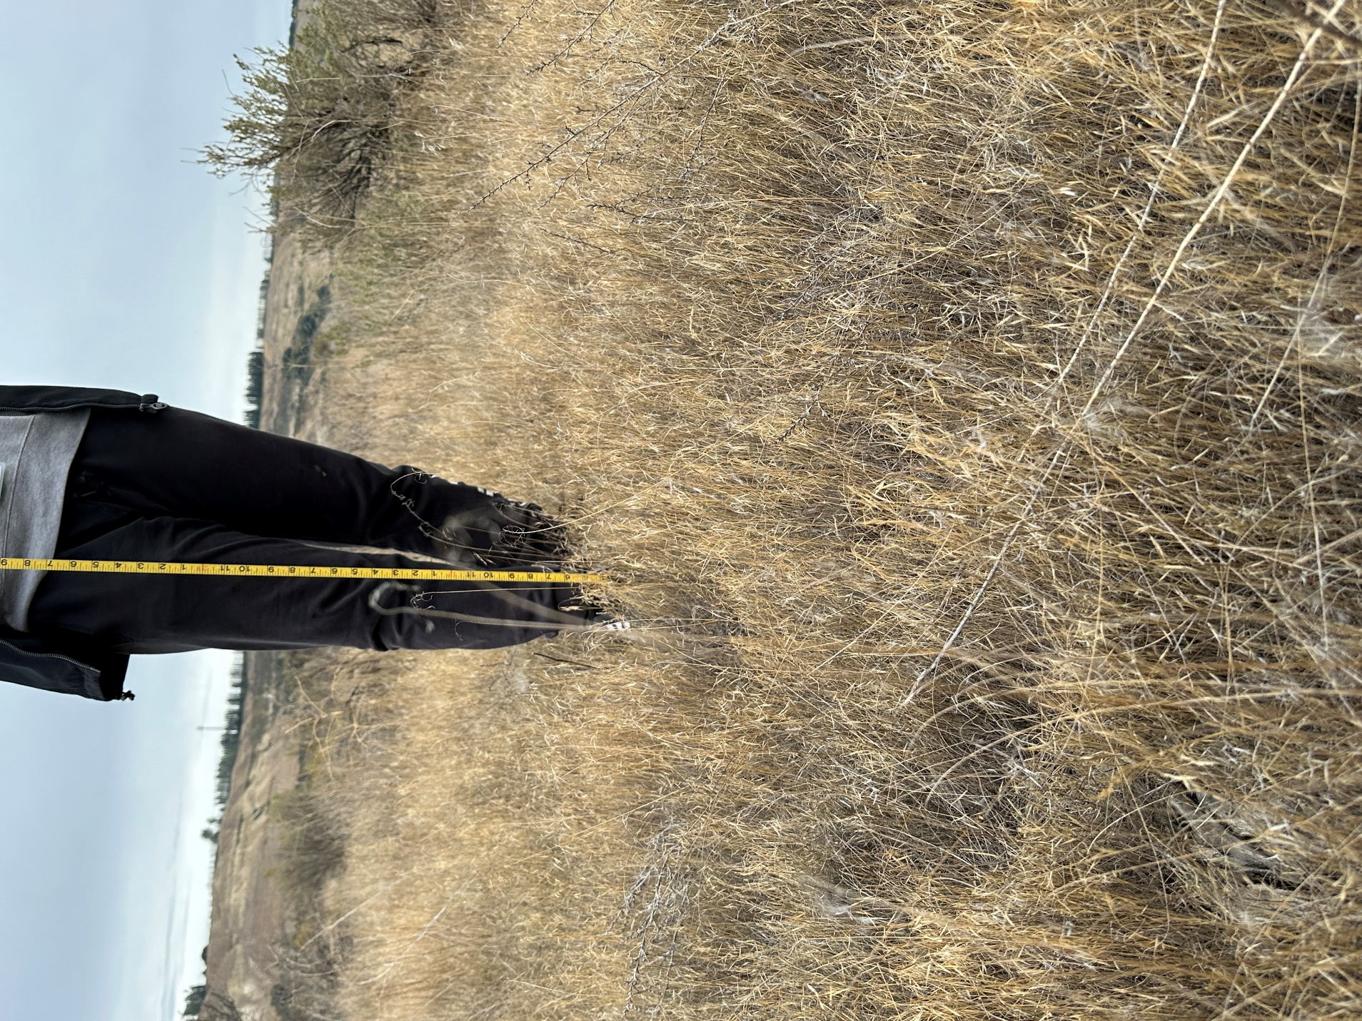

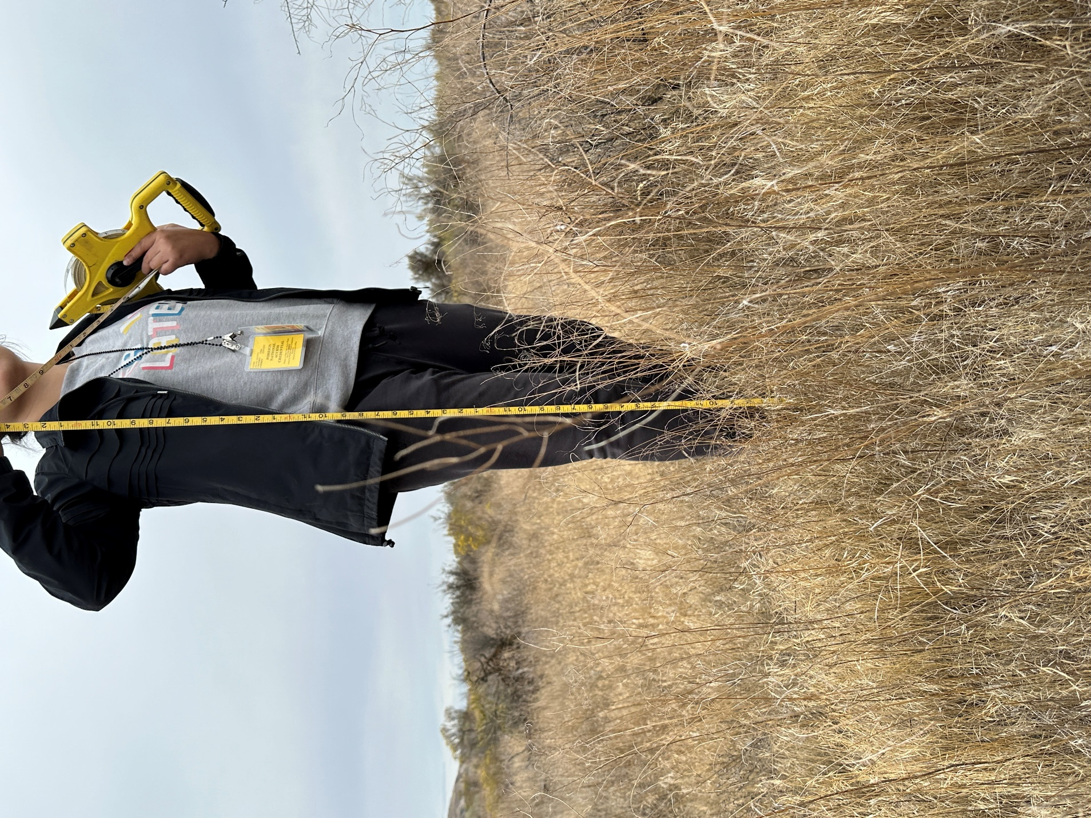

## Surroundings

